Mini Project
UNC504: Artificial Intelligence

Title


Submitted by:
Name of students with roll no

Submitted to:
Department of ECE

THAPAR INSTITUTE OF ENGINEERING & TECHNOLOGY, PATIALA, PUNJAB

November 2023
Table of Contents

Sr. No | Content | Page No
1 | Introduction (objectives and problem statement with suitable diagram) Max 2 pages | 1-2
2 | Data Preparation (detail introduction of dataset used) 1 page
3 | Exploratory Data Analysis (various EDA operation if you have applied) Max 2 pages
4 | Methods Used (define and discuss all classification/regression/learning and other models you have used) Max 2 pages
5 | Results and Evaluation (include all plots, graphs with proper numbering and name) Max 3 pages
6 | Conclusion 1 pages
7 | References

- Introduction
(objectives and problem statement with suitable diagram)
  - Overview

  - Problem Definition and Scope

- Data Preparation

2.1 Dataset Used (detailed description of data with its name, origin, owner, type, country, size, column names etc )

- Exploratory Data Analysis

(only for projects using classification or regression or Machine and Deep Learning)

This section must contain details of the following: Getting Insights About the Dataset (all operation we have applied during data manipulation)
Handling Missing Values (if applicable)
Data Encoding (If applicable)
Data visualization (discuss all charts and plots u have used)
Handling Outliers (If applicable)

(only for projects using Reinforcement Learning)
Dataset consists of:
State (S): Current situation of the agent
Action (A): Decision taken by agent
Reward (R): Feedback signal
Next State (S')
Operations performed:
Episode-wise data collection
State space analysis (discrete/continuous)
Action distribution analysis
Reward trend analysis over episodes
Insights:
Identified frequently visited states
Observed agent learning behavior over time
Checked reward convergence patterns

(only for projects using Q Learning or TD Learning)

Data format (experience tuples):

(State, Action, Reward, Next State)

Additional elements in Q-learning:

Q-table: stores value of each (state, action) pair

Operations performed:

Episode-wise tracking of Q-values

State-action visit frequency analysis

Reward accumulation per episode

Insights:

Identified which state-action pairs are most important

Observed how Q-values evolve from random

- Methods Used
4.1 Algorithm (discuss all classification/regression/learning and other models you have used)

- Results and Evaluation
  - Results (should be in order)
Sample
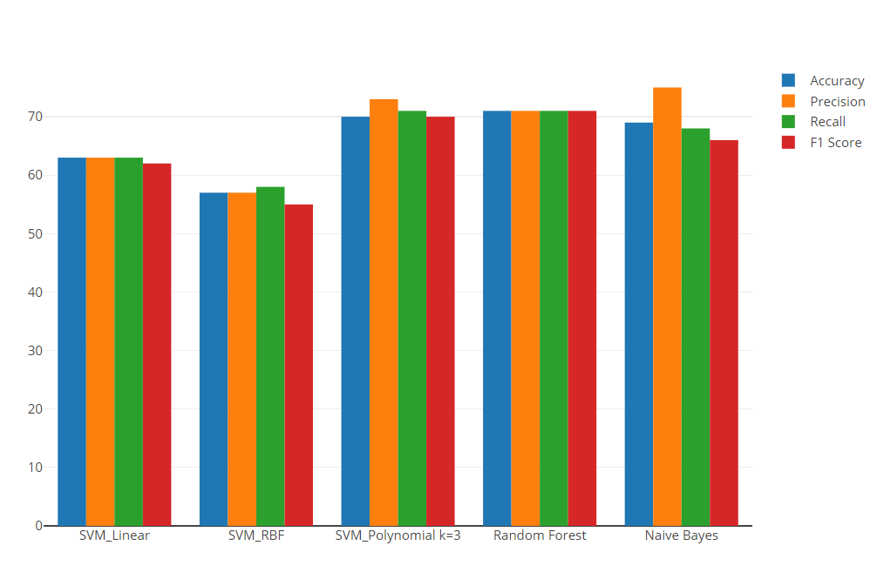
Fig 1. Comparison of Precision Recall and F1 Score for Different Classifiers

Result discussion (why a specific technique works and others fails)

- Conclusion

  - Conclusion
  - Each Members Contribution in detail

- References

